Copyright for test papers and marking guides remains with West Australian Test Papers.
The papers may only be reproduced within the purchasing school according to the advertised conditions of sale.
Test papers must be withdrawn after use and stored securely in the school until Wednesday 11th October 2017

HUMAN BIOLOGY

Units 3 and 4

2017

Name: _______________________________________________________

Teacher: ___________________________________________________

TIME ALLOWED FOR THIS PAPER

Reading time before commencing work: Ten minutes
Working time for the paper: Three hours

MATERIALS REQUIRED/RECOMMENDED FOR THIS PAPER
To be provided by the supervisor:
- This Question/Answer Booklet
- Multiple Choice Answer Sheet

To be provided by the candidate:
- Standard items: Pens, pencils, eraser or correction fluid, ruler, highlighter, ruler.
- Special items: Calculators satisfying the conditions set by the Schools
Curriculum and Standards Authority for this subject.

IMPORTANT NOTE TO CANDIDATES
No other items may be taken into the examination room. It is your responsibility to ensure that you do not have any unauthorised notes or other items of a non-personal nature in the examination room. If you have any unauthorised material with you, hand it to the supervisor before reading any further.

Structure of this paper

Section | Suggested working time | Number of questions available | Number of questions to be attempted | Marks | Percentage
SECTION ONE:  Multiple-choice | 40 minutes | 30 | All | 30 | 30
SECTION TWO:  Short answers | 90 minutes | 9 | All | 100 | 50
SECTION THREE:  Extended answers | 50 minutes | 3 | 2 | 40 | 20
 |  |  | Total marks | 170 | 100

Instructions to candidates
1. The rules for the conduct of Western Australian external examinations are detailed in the Year 12 Information Handbook 2017. Sitting this examination implies that you agree to abide by these rules.
2. Answer the questions according to the following instructions.

Section One: Answer all questions on the separate Multiple-choice Answer Sheet provided. For each question shade the box to indicate your answer. Use only a blue or black pen to shade the boxes. If you make a mistake, place a cross through that square, do not erase or use correction fluid, and shade your new answer. Marks will not be deducted for incorrect answers. No marks will be given if more than one answer is completed for any question.

Sections Two and Three: Write your answers in this Question/Answer Booklet.

3. You must be careful to confine your responses to the specific questions asked and to follow any instructions that are specific to a particular question.
4. Spare pages are included at the end of this booklet. They can be used for planning your responses and/or as additional space if required to continue an answer.
- Planning: If you use the spare pages for planning, indicate this clearly at the top of the page.
- Continuing an answer: If you need to use the space to continue an answer, indicate in the original answer space where the answer is continued, i.e. give the page number. Fill in the number of the question(s) that you are continuing to answer at the top of the page.
Section One: Multiple-choice 30% (30 Marks)
This section has 30 questions. Answer all questions on the separate Multiple-choice Answer Sheet provided. For each question shade the box to indicate your answer. Use only a blue or black pen to shade the boxes. If you make a mistake, place a cross through that square, do not erase or use correction fluid, and shade your new answer. Marks will not be deducted for incorrect answers. No marks will be given if more than one answer is completed for any question.
Suggested working time: 40 minutes.

- Clusters of neuron cell bodies found in the central nervous system are termed

  - nerve clusters.
  - ganglia.
  - axons.
  - nuclei.

- Regulation of the nervous system is different from that of endocrine regulation in that the nervous system

  - is quick, precise and localised.
  - is slower and more penetrative.
  - has longer lasting effects.
  - does not require conscious activity.

- A patient with symptoms of fluctuating body temperature, intense thirst and insomnia is likely to have a dysfunction of the

  - medulla oblongata.
  - hypothalamus.
  - pituitary gland.
  - cerebellum.

- During repolarization of the neurone membrane,

  - sodium ions rapidly move to the outside of the cell.
  - sodium ions rapidly move to the inside of the cell.
  - potassium ions rapidly move to the outside of the cell.
  - potassium ions rapidly move to the inside of the cell.

- Consider the following statements.

- All of its neurones release acetylcholine as the primary neurotransmitter substance.
- The cell bodies of its pre-ganglionic neurones lie in the cervical and sacral spinal cord.
- The cell bodies of its post-ganglionic neurones lie in or near the organ innervated.

Which one of the following statements is true about the parasympathetic division of the autonomic nervous system?

  - All are true.
  - None is true.
  - I and III are true.
  - II is true.

Refer to the diagram given below to answer Question 6.
Figure 1
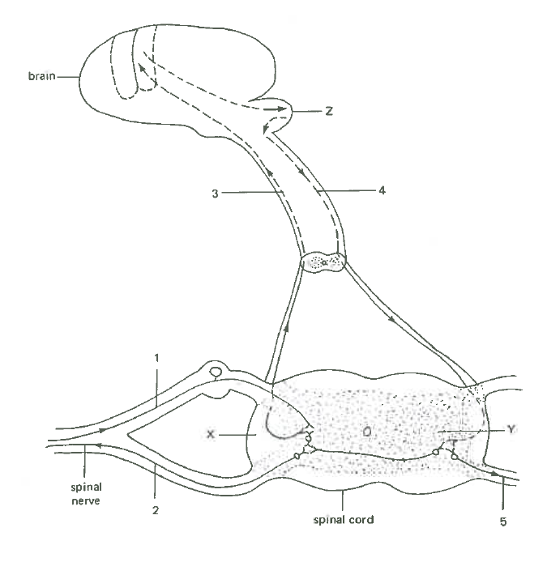

- Determine which of the following neural pathways would belong in a reflex action.

  - 1 2
  - 3 4 5
  - 1 3 4 2
  - 4 2
- Abnormal production of anti-diuretic hormone (ADH) could result from the dysfunction of
the

  - anterior pituitary gland.
  - hypothalamus.
  - adrenal glands.
  - medulla oblongata.

- Which one of the following will result in an increased breathing rate?
  - Increased oxygen levels detected by the hypothalamus
  - Decreased carbon dioxide levels detected by the hypothalamus
  - Stimulation of the chemoreceptors by increased carbon dioxide
  - Stimulation of the sympathetic nerves to the lungs

- Amine hormones

  - enter the target cells through proteins channels.
  - diffuse into a cell through the phospholipid bilayer.
  - enter the target cell by active transport.
  - bind with the membrane receptors in order to affect a target cell.

- For an individual suffering from diabetes mellitus, glucose can be detected in the urine (glucosuria). Which one of the following is the best explanation for glucosuria?

  - There is too much glucose in the diet so the body cannot cope with it.
  - There is too much glucose in the filtrate so the kidney is overwhelmed and cannot reabsorb it all.
  - The glomerulus of the kidney is not functioning properly and not reabsorbing enough of glucose, sodium and most of the essential ions.
  - There is too much glucose in the filtrate due to the lack of activity of glucagon.

- When the body fails to distinguish self from non-self antigens, this leads to ___________.

  - tissue rejection
  - hypersensitivities
  - allergies
  - autoimmune disorders

- The main components of the immune response involved in organ rejection are

  - red blood cells, white blood cells and antigens.
  - T cells, B cells and red blood cells.
  - antibodies, T cells and B cells.
  - antibiotics and white blood cells.

- In haemoglobin, the amino acid sequence of the beta (ß) polypeptide chains differs among the species which possess the molecule. The beta chains of the species shown in the table below were analysed. The number of amino acid differences between humans and each of the species was counted and ranged between 8 and 127.
Which of the following would be consistent with the proposed evolutionary relationships between each of the organism and humans?

 | Amino acid differences
 | dog | earthworm | frog | lamprey | Rhesus monkey
a. | 15 | 127 | 67 | 125 | 8
b. | 67 | 15 | 127 | 8 | 67
c. | 125 | 8 | 67 | 15 | 127
d. | 127 | 125 | 8 | 67 | 15

- What role do mucous membranes and cilia play in the body’s first line of defence against pathogens?

  - They cause cell death to cut off pathogens.
  - They form part of a barrier preventing pathogens from entering.
  - They remove pathogens as part of the inflammatory response.
  - They recognise pathogens passing through the lymphatic system.

- Which of the following statements is NOT correct?

  - Heterozygous individuals with one Tay-Sachs allele appear to have increased resistance to tuberculosis.
  - Heterozygous individuals with one sickle-cell anaemia allele have a survival advantage in areas where malaria is prevalent.
  - Thalassaemia is an autosomal recessive disease in which anaemia results from the formation of distorted red blood cells.
  - Cystic fibrosis is an autosomal recessive disease caused by a mutation preventing the gene from producing a protein that will be able to function in the body.

- The Amish population of Eastern Pennsylvania started as a small number of German immigrants, about 200 individuals. The Amish carry an unusually high frequency of a number of inherited disorders, such as dwarfism (Ellis-van Creveld syndrome), polydactyly (extra fingers or toes), abnormalities of the nails and teeth, and in about half of the individuals, a hole between the two upper chambers of the heart. The most likely explanation for the Amish population to experience high frequency of these disorders is

  - the founder effect.
  - geographical isolation.
  - natural selection.
  - speciation.

Refer to the diagram below to answer Question 17.

C

G

T

A

C

- The sequences of bases in the fully-assembled DNA strand would read

  - CGTAC
  - CATGC
  - CTCAG
  - GATCC

Refer to the following diagram to answer Question 18.
Figure 4
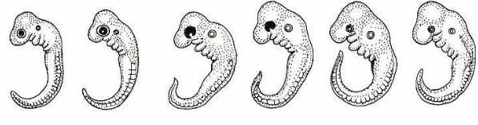
- The diagram above shows all the early embryos of vertebrates which are characterised by the absence of paired appendages and the presence of a well-developed tail. Which of the following supports the theory of evolution?

  - They all have features that are characteristic of their species.
  - They all have features that do not occur in the adult form.
  - All features of the adult form can be recognised in the embryo.
  - None of the features at the embryonic stage is typical of modern vertebrates.
- The age of the Earth and its inhabitants has been determined through two complementary lines of evidence; namely

  - relative dating (eg. stratigraphy) and absolute dating (eg. radio-isotope dating).
  - absolute dating (eg. fluorine dating) and relative dating (eg. index fossils).
  - absolute dating (eg. potassium-argon) and relative dating (eg. tree-ring dating).
  - absolute dating (eg. radio-carbon) and relative dating (eg. tree-ring dating).

Refer to the diagrams below to answer Question 20 and 21.
Figure 5
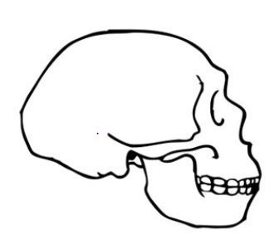  P | 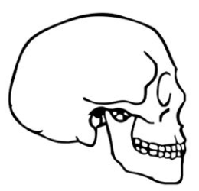  Q
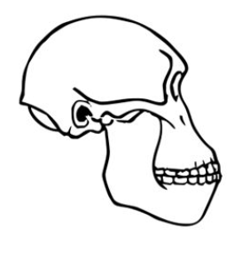  R | 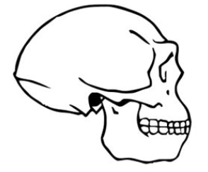  S

- Which of the following describes the correct order of the hominin skulls from the earliest to the most recent?

  - S R Q P
  - R S Q P
  - R P S Q
  - R S P Q

Figure 6

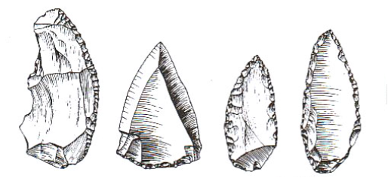

- Choose the hominin (P Q R S) who made the tools as shown in the diagram above.

a. Hominin P
b. Hominin Q
c. Hominin R
d. Hominin S

- Hormone replacement therapy was used to treat a patient who suffered from low levels of salt in his blood. Identify the hormone used for this treatment.

  - aldosterone
  - thymosins
  - parathyroid hormone
  - insulin

- A mineralised remnant of a primate skull, believed to be several million years old, is brought into the lab for dating. Which of the following suggests the best reason why carbon-14 dating may not be a useful technique?

a. Too little carbon content is present.
b. The ratio of carbon-14 to carbon-12 in the atmosphere is variable.
c. Carbon-14 has a relatively short half-life.
d. The radioactive decay of carbon-14 is not consistent.

Refer to the diagram below to answer Question 24.
Nervous System

Central Nervous System
1

Afferent
Efferent
2
Brain

4
3
Autonomic

Figure 7
Sympathetic
5

- Which of the following correctly identifies each of the missing components of the nervous system?

Component | 1 | 2 | 3 | 4 | 5
a. | Peripheral  Nervous System | Spinal cord | Parasympathetic | Sensory | Sensory
b. | Peripheral  Nervous System | Spinal cord | Somatic | Sensory | Parasympathetic
c. | Peripheral  Nervous System | Spinal cord | Sensory | Parasympathetic | Somatic
d. | Somatic Nervous System | Peripheral  Nervous  System | Spinal cord | Sensory | Parasympathetic

- Which of the following roles best describes the function of cytotoxic T-cells?

  - They are important in inflammatory responses and allergic reactions.
  - They are necessary for B cell activation.
  - They recognise antigens, bind to antigens and produce antibodies to counteract cancerous cells or virus infected cells.
  - They are the main cells in the body’s cell-mediated immune response.

- Which of the following is unlikely to occur when the core body temperature begins to fall?

  - vasoconstriction of the arterioles in the skin
  - shivering
  - increase in voluntary activity
  - decrease in cellular metabolism

- The primitive ancestor of the hominins is thought to have their mode of locomotion through trees by brachiation. Which of the following characteristics of a brachiator, such as the gibbon, is likely to be of an advantage for bipedalism?

  - C-shaped spine
  - precision grip
  - rotating shoulder joints
  - long forelimbs

- Bioinformatics is most appropriately defined as an area of biological science in which

  - the genome sequences of different species can be compared through computational analysis.
  - the use of computers is instrumental to describe molecular components of living things.
  - the micro-structural features of related organisms can be compared and analysed.
  - the biochemical techniques of sequencing amino acids can be computed and the degree of similarity can be established.

- The analysis of second-hand data involves the use of data

  - obtained from an experiment that has been replicated.
  - collected by another scientist.
  - that are usually not accurate or reliable.
  - that have been passed down as not valid by another scientist.

- Which one of the following statements best describes the relationship between theories and hypotheses?

  - Theories and hypotheses refer to the same thing.
  - Theories are proven hypotheses.
  - Theories can be tested experimentally, whereas hypotheses cannot.
  - Theories are substantiated by a larger amount of evidence than hypotheses.

Section Two: Short answer 50% (100 Marks)
This section has nine (9) questions. Answer all questions. Write your answers in the spaces provided. Spare pages are included at the end of this booklet. They can be used for planning your responses and/or as additional space if required to continue an answer.
  - Planning: If you use the spare pages for planning, indicate this clearly at the top of the page.
  - Continuing an answer: If you need to use the space to continue an answer, indicate in the original answer space where the answer is continued, i.e. give the page number. Fill in the number of the question(s) that you are continuing to answer at the top of the page.

Suggested working time: 90 minutes.

Question 31 (12 marks)

- Complete the table by matching the receptors to the corresponding stimuli. (3 marks)
Receptors | Stimuli
Thermoreceptors | Temperature/heat or cold
Osmoreceptors

 | Pressure, touch, sound
 | Pain, injury, heat or chemicals

- Outline the events in the transmission of information from one neurone to another across a synapse. (3 marks)

_________________________________________________________________________
_________________________________________________________________________
_________________________________________________________________________
_________________________________________________________________________

_________________________________________________________________________

- Explain why hyperpolarisation reduces the likelihood of a new action potential being created. (2 marks)

_________________________________________________________________________

_________________________________________________________________________

_________________________________________________________________________

- The table below compares the number of synapses with the speed of transmission in three neural pathways X, Y and Z.
Neural pathway | Number of synapses | Speed of transmission (m/s)
X | 12 | 40
Y | 9 | 64
Z | 5 | 89

- Calculate the percentage increase in transmission speed when the number of synapses is reduced from 12 to 9. (2 marks)

______________________________________________________________________

______________________________________________________________________

- Explain why the neural pathways of reflex arcs have very few synapses. (2 marks)

______________________________________________________________________

______________________________________________________________________

______________________________________________________________________

Question 32 (10 marks)
A carpenter pricked his finger on a rusty hook on a broken door. Soon after he noticed that the injured finger was red and swollen. Some time later, he felt a throbbing sensation in his arm. Later in the day, he was unwell, running a high fever, broke out in a cold sweat and had to take the rest of the day off work. His doctor prescribed him a course of antibiotics.

- Identify and explain the defence mechanisms used by the body in response to the injury.
(4 marks)

_________________________________________________________________________
_________________________________________________________________________
_________________________________________________________________________
_________________________________________________________________________

_________________________________________________________________________

- What are two ways in which antibiotics can act to fight the infection? (2 marks)

_________________________________________________________________________
_________________________________________________________________________
_________________________________________________________________________

- Describe the thermoregulatory mechanisms that occur during and immediately after a fever.
(4 marks)

_________________________________________________________________________
_________________________________________________________________________
_________________________________________________________________________
_________________________________________________________________________

_________________________________________________________________________

Question 33 (12 marks)
According to the WA’s Health Minister John Day and former Federal Health Minister Sussan Ley, meningococcal outbreaks in Western Australia since early 2016 necessitated a nationwide vaccine program before winter of 2017. Meningococcal disease is a life-threatening disease caused by different strains of the bacterium Neisseria meningitidis. Commonly found in the upper respiratory tract of infected people, the bacterium is spread through coughing, sneezing or close contact with infected people, causing blood poisoning and meningitis.
It was also reported that Perth toddler Robbie Buchan lost most of his four limbs after he contracted the B strain of meningococcal. Each injection of the B strain vaccine costs about $150 and babies under one year of age need up to three injections. The B strain vaccine is undergoing a global shortage and limited supplies meant availability would be delayed for a while. While there are more cases of the W strains of the disease, there are efforts to make the vaccines for both B and W strains more accessible to the public.
- Suggest a reason why vaccines are required for all babies at birth and at the age of two, four and six months. (1 mark)

______________________________________________________________________

______________________________________________________________________

- Outline the response of B lymphocytes to the meningococcal vaccine. (3 marks)

_________________________________________________________________________
_________________________________________________________________________
_________________________________________________________________________

- Explain two ways in which the routine vaccination for meningococcal may cause a decrease in the incidence of the disease in Western Australia. (4 marks)

_________________________________________________________________________
_________________________________________________________________________
_________________________________________________________________________
_________________________________________________________________________

_________________________________________________________________________

- Why is the B meningococcal vaccine unable to provide protection against other strains of the same bacterium? (2 marks)

_________________________________________________________________________
_________________________________________________________________________
_________________________________________________________________________

- Describe one socio-cultural and one economic factor that influence whether or not parents
choose to have their children immunised. (2 marks)

_________________________________________________________________________
_________________________________________________________________________
_________________________________________________________________________

Question 34 (10 marks)
Tay-Sachs disease is a disorder of lipid metabolism which occurs as a result of a gene mutation. The recessive allele prevents the gene from producing a protein that will be able to function in the body. These recessive mutations are considered `lethal recessives’, and in the case of the Tay-Sachs disease, this leads to the death of the embryo or foetus, or the early death of a child.
- Distinguish between a gene mutation and a chromosomal mutation. (2 marks)

_________________________________________________________________________

_________________________________________________________________________
_________________________________________________________________________

- Explain why Tay-Sachs disease is considered a lethal recessive condition. (2 marks)

_________________________________________________________________________

_________________________________________________________________________

- Using examples, explain how a lethal recessive mutation such as the Tay-Sachs disease can bring about changes in the gene pool through the two evolutionary mechanisms:
- genetic drift (3 marks)
_________________________________________________________________________
_________________________________________________________________________
_________________________________________________________________________
_________________________________________________________________________
- natural selection (3 marks)
_________________________________________________________________________
_________________________________________________________________________
_________________________________________________________________________
_________________________________________________________________________
Question 35 (10 marks)
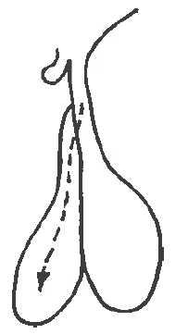Organ A 
Directly stimulates fat utilisation
GHHH

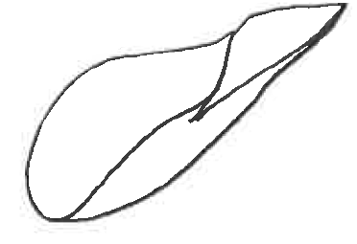
Metabolic Effects
Liver Figure 8
Refer to the diagram as shown above to answer this question.

- Identify the organ A which releases the growth hormone. (1 mark)

________________________________________________________________________

- Explain how the two lobes of organ A are different with respect to their relationship with the hypothalamus. (2 marks)

_________________________________________________________________________
_________________________________________________________________________
_________________________________________________________________________
_________________________________________________________________________

- Describe the process of how growth hormones are released from organ. (2 marks)
_________________________________________________________________________
_________________________________________________________________________
_________________________________________________________________________
- Describe the metabolic effects of growth hormone. (2 marks)

_________________________________________________________________________
_________________________________________________________________________
_________________________________________________________________________

- Genetically engineered bacteria have been used to produce human growth hormone through a process called recombinant DNA technology. Outline the steps involved in this process. (3 marks)

_________________________________________________________________________
_________________________________________________________________________
_________________________________________________________________________
_________________________________________________________________________

_________________________________________________________________________

Question 36 (12 marks)
An experiment was carried out with two groups of people. Group A is the control group while Group B has type 1 diabetes. Every 15 minutes, blood samples were taken from all members of both groups and the mean concentrations of insulin, glucagon and glucose were determined. After one hour, each person was given a glucose drink. All results for the control group are shown in the graph below. Blood samples were taken every 15 minutes for the next 4 hours.

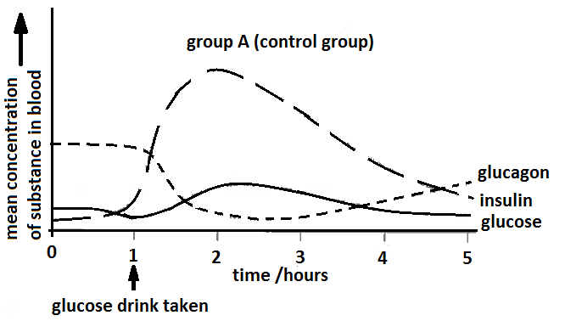
Figure 9

- Name two hormones, other than insulin and glucagon, that are involved in regulating blood glucose concentration. (2 marks)

_________________________________________________________________________

_________________________________________________________________________

- Using the information from the graph above, explain the changes in the blood glucose concentration in group A after drinking the glucose. Refer to the role of insulin and glucagon in regulating blood glucose level in your answer. (6 marks)

_________________________________________________________________________
_________________________________________________________________________
_________________________________________________________________________
_________________________________________________________________________
_________________________________________________________________________
_________________________________________________________________________
________________________________________________________________________

________________________________________________________________________

- On the graph given below, sketch a curve to show what you would expect the mean concentrations of glucose, insulin and glucagon results of the members of Group B to be.
(3 marks)
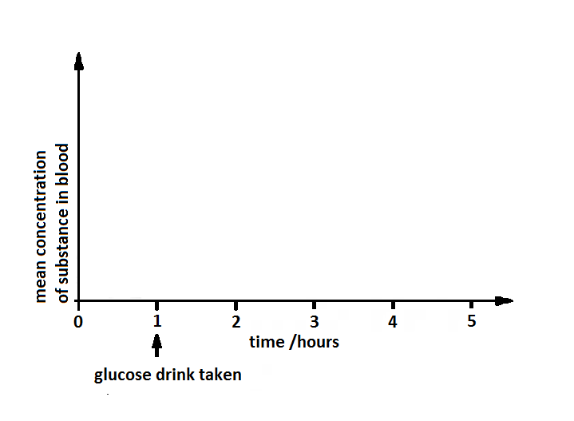

- Suggest what might happen to the blood glucose concentration of Group B if they fast for the next 24 hours. (1 mark)

________________________________________________________________________

________________________________________________________________________

Question 37 (14 marks)
Zika virus (ZIKV) is responsible for major unprecedented outbreaks and epidemics and has been causally associated with foetal microcephaly. The development of a safe and effective ZIKV vaccine is now an urgent global health priority. The following experiment shows the use of a type of vaccine that protects against ZIKV in rhesus monkeys. A purified inactivated virus vaccine, VRC 5288, induced ZIKV-specific neutralizing antibodies and completely protected monkeys against ZIKV strains from both Brazil and Puerto Rico.
Before the clinical development of ZIKV vaccines, the following investigation was conducted to determine the relationship between the number of correct dosages of the ZIKV vaccine and its effectiveness to produce an immune response or immunogenicity. Immunogenicity is measured by the amount of neutralizing antibodies (Ab) produced.
Method:
- There are four groups of six monkeys (specifically Rhesus macaques).
- Group A received a single 1 mg dose of VRC 5288 at week 0.
- Group B received a single 1 mg dose of VRC 5288 at week 0 and another 1 mg dose of VRC 5288 at Week 4.
- Group C received a single 4 mg dose of VRC 5288 at week 0 and another 4 mg dose of VRC 5288 at Week 4.
- Group D is the control group.
- Every week, the monkeys’ blood sera were assayed by ELISA [Enzyme Linked Immunosorbent Assay] for ZIKV neutralising antibodies (Ab). The average Ab concentration for each group is given in Table 1.

Eight weeks after immunisation, all groups of animals were challenged subcutaneously with a ZIKV strain from Puerto Rico, PRVABC 59. Blood samples were collected daily for polymerase chain reaction (PCR) analysis of the ZIKV genome copies in plasma to determine virus load (viremic level).

Table 1
 | Average antibody concentration of arbitrary units/ genome copies per mL
 | Group A  VRC 1 mg x 1 | Group B  VRC 1 mg x 2 | Group C  VRC 4 mg x 2 | Group D
Week 0 | 0 | 0 | 0 | 0
Week 1 | 0 | 0 | 0 | 0
Week 2 | 2.00 | 2.50 | 2.75 | 0
Week 3 | 3.25 | 3.50 | 3.75 | 0
Week 4 | 3.50 | 3.75 | 4.25 | 0
Week 5 | 3.75 | 4.00 | 4.50 | 0
Week 6 | 3.50 | 4.25 | 4.75 | 0
Week 7 | 3.25 | 4.50 | 5.00 | 0
Week 8 | 3.00 | 4.25 | 4.75 | 0
Viremic Level  (Presence of virus in the blood) after challenge | High  +++ | Negligible  - | Negligible  - | Very High  +++++

- Based on the data given in Table 1, plot a graph to show the relationship between the binding antibody concentrations for each group over an eight-week period post vaccination period. (6 marks)
(If required, a spare grid can be found on page 38.)


- Describe a control group (Group D) that could be used for this experiment. (1 mark)
_________________________________________________________________________
_________________________________________________________________________

- State one factor involving the monkey’s blood serum that the scientists would have to determine before they begin the experiment. (1 mark)
_________________________________________________________________________
_________________________________________________________________________

- Describe the immunogenic responses of the groups being investigated. (2 marks)

_________________________________________________________________________
_________________________________________________________________________
_________________________________________________________________________

- What could be the conclusion of this investigation? (1 mark)
_________________________________________________________________________
_________________________________________________________________________

- What further investigation is needed before the VRC 5288 can be evaluated in human trials? (1 mark)

________________________________________________________________________
________________________________________________________________________

- Scientists in this investigation are now working on evaluating both protein-based, wholly inactivated ZIKV vaccine, and live-attenuated vaccine approaches. Explain the difference between these two vaccine approaches. (2 marks)

______________________________________________________________________

______________________________________________________________________

______________________________________________________________________________
Question 38 (10 marks)
Refer to the following table to answer the following question.

Table 2: Relationship between humans and great apes using DNA differences

Primates being compared | DNA difference (%)
Human - chimpanzee | 1.2
Chimpanzee - gorilla | 1.2
Human - gorilla | 1.6
Chimpanzee - orang utan | 1.9
Human - orang utan | 2.5
Gorilla - orang utan | 2.5

- Use the information given in the table above to construct a phylogenetic tree to illustrate the evolutionary relationships of the great apes and humans. (3 marks)

- The drawings below show some stone tools. A1 and A2 belong to a different tool culture from B1 and B2.
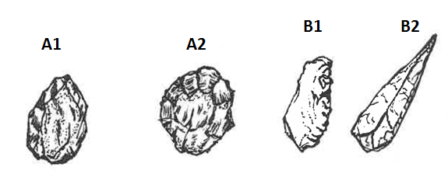
Figure 10
- Identify the tool culture of B1 and B2. (1 mark)

________________________________________________________________________

- Give two pieces of evidence to suggest that A1 and A2 are older than tools B1 and B2. (2 marks)
_________________________________________________________________________
_________________________________________________________________________

- Suggest two possible uses of tools such as A1 and A2. (2 marks)
_________________________________________________________________________
_________________________________________________________________________
_________________________________________________________________________

- Describe how tools B1 and B2 might have been made. (2 marks)

_________________________________________________________________________
_________________________________________________________________________
Question 39 (10 marks)
The images below show front, side and bottom views of the skull of an Australopithecine.

Figure 11

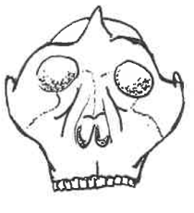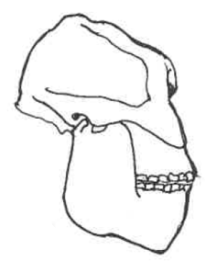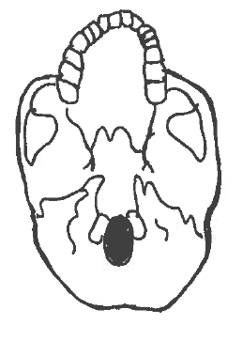

- Describe how an examination of the skull as shown above could give evidence about the
posture, locomotion, brain size and diet of an Australopithecine. (4 marks)

_________________________________________________________________________
_________________________________________________________________________
_________________________________________________________________________
_________________________________________________________________________

_________________________________________________________________________

- Compare the posture and brain size of an Australopithecine and a gorilla. State the differences between the early hominid and the great ape. (2 marks)

_________________________________________________________________________
_________________________________________________________________________
_________________________________________________________________________

- The Laetoli footprints (a set of footprints) found in volcanic ash in Tanzania are 3.56 million years old and are believed to have been made by Australopithecus afarensis.

i. Outline two methods by which it would be possible to determine how long ago the Australopithecine lived. (2 marks)

_________________________________________________________________________
_________________________________________________________________________
_________________________________________________________________________

ii. State the assumptions that must be made using these two methods of dating.
(2 marks)

_________________________________________________________________________
_________________________________________________________________________
_________________________________________________________________________

Section Three: Extended answer 20% (40 Marks)
This section contains three (3) questions. You must answer two (2) questions. Make sure you clearly indicate which question you are answering and write your answers in the space provided.
Spare pages are included at the end of this booklet. They can be used for planning your responses and/or as additional space if required to continue an answer.
- Planning: If you use the spare pages for planning, indicate this clearly at the top of the page.
  - Continuing an answer: If you need to use more space to continue an answer, indicate in the original answer space where the answer is continued, i.e. give the page number. Write the number of the question(s) that you are continuing to answer at the top of the additional space page.
Responses could include clearly labelled diagrams with explanatory notes; lists of points with linking sentences; clearly labelled tables and graphs; and annotated flow diagrams with introductory notes.
Suggested working time: 50 minutes.

Question 40 (20 marks)
One of the most exciting discoveries in recent years is the fossil skeleton of a new species, Homo floresiensis, found in the Liang Bua Cave on the Island of Flores in Indonesia by Australian and Indonesian palaeontologists. The discovery was announced to the world in 2004, and the fossil, nick-named `the hobbit’, lived as recently as 18 000 years ago until a massive volcanic eruption decimated them. The fossil skeleton stands only one metre tall and has a small brain size of 380 cm³. It was found with stone tools and the remains of a pygmy form of extinct elephants Stegodon and burnt remains of smaller animals.

- Describe the physical features of this fossil skeleton that would place it in the genus `Homo’. Also identify any discovered features that challenge our understanding of the evolution of the genus `Homo’. (8 marks)

- What evidence and techniques could be used to indicate this fossil skeleton may be related to Homo erectus? (4 marks)

- Fossils included in the genus `Homo’ are described as `gracile’ hominins. Describe how the `Homo’ genus is different from the Australopithecines. (8 marks)

Question 41 (20 marks)

- A minute sample of DNA has been obtained from an individual for paternity testing and to establish any possible link with a rare genetic disorder.

i. Outline two named techniques in biotechnology that are carried out before proceeding to
DNA sequencing of the genome. (11 marks)

ii. Rapid developments in genomic testing methods have made the sequencing of a
person’s DNA faster and cost-efficient. List some ethical issues involved in the use of the
genomic information as a `lifetime health resource’. (3 marks)

- Define gene therapy and cell replacement therapy. For each of these techniques, state an example of its application and discuss any ethical issues raised by this kind of human intervention. (6 marks)

Question 42 (20 marks)

- The Rotary Beachside Festival Fun Run in Safety Bay, Rockingham WA on 26 March 2017 was scheduled to start in the morning at 9 am. The Fun Run was to be a 21 km half marathon or 10 km or 5 km fun run, and the competitors had 4 hours to finish the event. The event organisers took into account the expected weather conditions when scheduling this event to allow the athletes to perform in the most suitable conditions.
The expected weather conditions were as follows:
- mean maximum daily temperature: 23.4ºC
- mean 9 am temperature: 16.9 ºC
- mean 9 am humidity: 62%
- mean 3 pm temperature: 22.7 ºC
- mean 3 pm humidity: 52%

During this event, the athletes need to maintain their homeostasis of body temperature and body fluid concentrations. Outline these two homeostatic mechanisms and the interactions between them in an athlete participating in this event during the given expected weather conditions for March in Rockingham, WA. (12 marks)

- Using hyperthyroidism as an example, discuss how a chronic disease can occur when there is a disruption of homeostasis in the body, including how it can be treated or controlled.
(8 marks)

Question number: ________________
_____________________________________________________________________________________________________________________________________________________________________________________________________________________________________________________________________________________________________________________________________________________________________________________________________________________________________________________________________________________________________________________________________________________________________________________________________________________________________________________________________________________________________________________________________________________________________________________________________________________________________________________________________________________________________________________________________________________________________________________________________________________________________________________________________________________________________________________________________________________________________________________________________________________________________________________________________________________________________________________________________________________________________________________________________________________________________________________________________________________________________________________________________________________________________________________________________________________________________________________________________________________________________________________________________________________________________________________________________________________________________________________________________________________________________________________________________________________________________________________________________________________________________________________________________________________________________________________________________________________________________________________________________________________________________________________________________________________________________________________________________________________________________________________________________________________________________________________________________________________________________________________________________________________________________________________________________________________________________________________________________________________________________________________________________________________________________________________________________________________________________________________________________________
Question number: ________________
_____________________________________________________________________________________________________________________________________________________________________________________________________________________________________________________________________________________________________________________________________________________________________________________________________________________________________________________________________________________________________________________________________________________________________________________________________________________________________________________________________________________________________________________________________________________________________________________________________________________________________________________________________________________________________________________________________________________________________________________________________________________________________________________________________________________________________________________________________________________________________________________________________________________________________________________________________________________________________________________________________________________________________________________________________________________________________________________________________________________________________________________________________________________________________________________________________________________________________________________________________________________________________________________________________________________________________________________________________________________________________________________________________________________________________________________________________________________________________________________________________________________________________________________________________________________________________________________________________________________________________________________________________________________________________________________________________________________________________________________________________________________________________________________________________________________________________________________________________________________________________________________________________________________________________________________________________________________________________________________________________________________________________________________________________________________________________________________________________________________________________________________________________________
Question number: ________________
_____________________________________________________________________________________________________________________________________________________________________________________________________________________________________________________________________________________________________________________________________________________________________________________________________________________________________________________________________________________________________________________________________________________________________________________________________________________________________________________________________________________________________________________________________________________________________________________________________________________________________________________________________________________________________________________________________________________________________________________________________________________________________________________________________________________________________________________________________________________________________________________________________________________________________________________________________________________________________________________________________________________________________________________________________________________________________________________________________________________________________________________________________________________________________________________________________________________________________________________________________________________________________________________________________________________________________________________________________________________________________________________________________________________________________________________________________________________________________________________________________________________________________________________________________________________________________________________________________________________________________________________________________________________________________________________________________________________________________________________________________________________________________________________________________________________________________________________________________________________________________________________________________________________________________________________________________________________________________________________________________________________________________________________________________________________________________________________________________________________________________________________________________________
Question number: ________________
_____________________________________________________________________________________________________________________________________________________________________________________________________________________________________________________________________________________________________________________________________________________________________________________________________________________________________________________________________________________________________________________________________________________________________________________________________________________________________________________________________________________________________________________________________________________________________________________________________________________________________________________________________________________________________________________________________________________________________________________________________________________________________________________________________________________________________________________________________________________________________________________________________________________________________________________________________________________________________________________________________________________________________________________________________________________________________________________________________________________________________________________________________________________________________________________________________________________________________________________________________________________________________________________________________________________________________________________________________________________________________________________________________________________________________________________________________________________________________________________________________________________________________________________________________________________________________________________________________________________________________________________________________________________________________________________________________________________________________________________________________________________________________________________________________________________________________________________________________________________________________________________________________________________________________________________________________________________________________________________________________________________________________________________________________________________________________________________________________________________________________________________________________________
Question number: ________________
_____________________________________________________________________________________________________________________________________________________________________________________________________________________________________________________________________________________________________________________________________________________________________________________________________________________________________________________________________________________________________________________________________________________________________________________________________________________________________________________________________________________________________________________________________________________________________________________________________________________________________________________________________________________________________________________________________________________________________________________________________________________________________________________________________________________________________________________________________________________________________________________________________________________________________________________________________________________________________________________________________________________________________________________________________________________________________________________________________________________________________________________________________________________________________________________________________________________________________________________________________________________________________________________________________________________________________________________________________________________________________________________________________________________________________________________________________________________________________________________________________________________________________________________________________________________________________________________________________________________________________________________________________________________________________________________________________________________________________________________________________________________________________________________________________________________________________________________________________________________________________________________________________________________________________________________________________________________________________________________________________________________________________________________________________________________________________________________________________________________________________________________________________________
Question number: ________________
_____________________________________________________________________________________________________________________________________________________________________________________________________________________________________________________________________________________________________________________________________________________________________________________________________________________________________________________________________________________________________________________________________________________________________________________________________________________________________________________________________________________________________________________________________________________________________________________________________________________________________________________________________________________________________________________________________________________________________________________________________________________________________________________________________________________________________________________________________________________________________________________________________________________________________________________________________________________________________________________________________________________________________________________________________________________________________________________________________________________________________________________________________________________________________________________________________________________________________________________________________________________________________________________________________________________________________________________________________________________________________________________________________________________________________________________________________________________________________________________________________________________________________________________________________________________________________________________________________________________________________________________________________________________________________________________________________________________________________________________________________________________________________________________________________________________________________________________________________________________________________________________________________________________________________________________________________________________________________________________________________________________________________________________________________________________________________________________________________________________________________________________________________________
Additional Working
_____________________________________________________________________________________________________________________________________________________________________________________________________________________________________________________________________________________________________________________________________________________________________________________________________________________________________________________________________________________________________________________________________________________________________________________________________________________________________________________________________________________________________________________________________________________________________________________________________________________________________________________________________________________________________________________________________________________________________________________________________________________________________________________________________________________________________________________________________________________________________________________________________________________________________________________________________________________________________________________________________________________________________________________________________________________________________________________________________________________________________________________________________________________________________________________________________________________________________________________________________________________________________________________________________________________________________________________________________________________________________________________________________________________________________________________________________________________________________________________________________________________________________________________________________________________________________________________________________________________________________________________________________________________________________________________________________________________________________________________________________________________________________________________________________________________________________________________________________________________________________________________________________________________________________________________________________________________________________________________________________________________________________________________________________________________________________________________________________________________________________________________________________________
Spare Graph Paper for Question 37



Acknowledgements

Section One – Multiple Choice Questions

Question 6 Diagram from: Tse Kwok Wing. (1988). Multiple Choice in Human Biology. Hong
Kong: Greenwood Press (p.54).

Question 18 – Picture of Comparative Embryology (Free) Retrieved 3 Jan 2017, from
https://www.bing.com/images/search?q=comparative+embryology+pictures+free&view=detailv2&qpvt=comparative+embryology+pictures+free&id=69CFD480542F85DB3A5D32AAA720060F5095EBFB&selectedIndex=1&ccid=6JGs7B2w&simid=608008684244766177&thid=OIP.Me891acec1db018abd2534e102742ca6fH0&ajaxhist=0

Question 20 – Hominin Skulls (Free) Retrieved 3 Jan 2017, from
https://www.bing.com/images/search?q=hominin+skulls+comparison+free+pictures&view=detailv2&&id=6FC3FD256ED13B05F8E562B6735E9E31A4A45A2B&selectedIndex=96&ccid=AlL63%2f6V&simid=608051092752500295&thid=OIP.M0252fadffe953f4797063326705c130ao0&ajaxhist=0

Question 21 – Tool Culture (Free) Credited to James Dilley – Ancient Craft.
Retrieved 3 Jan 2017, from http://humanpast.net/images/.JPG.

Section Two – Short Questions

Question 33 Adapted from: Regina Titelius, “State steps in on jabs” by Regina Titelius, The
Sunday Times. 11 December 2016, p.18

Question 35 Drawing - Courtesy of S. Yap

Question 36 Graph – Courtesy of S. Yap and A. Altraide

Question 38 a Table 2 - Adapted from Human Perspectives Units 3 & 4 by Newton & Joyce, p.217
©2015 ISBN 9780170351218, with permission of Cengage Learning Australia

Question 38 b Drawing - Courtesy of S. Yap

Question 39 Drawing - Courtesy of S. Yap

